**A blog on objects and its internal representation in Javascript**

## **Introduction**

JavaScript is a versatile and powerful programming language, widely used for creating dynamic websites and web applications. One fundamental concept in JavaScript that developers must grasp is object representation. Objects are an essential part of JavaScript, allowing developers to create complex data structures and models. Understanding how object representation works is crucial for building efficient and maintainable code. In this comprehensive guide, we will delve into the intricacies of object representation in JavaScript, providing a thorough explanation to help developers deepen their understanding of this important concept.

## **What is object representation in JavaScript?**

Object representation in JavaScript refers to the way in which data is organized and stored within an object. Objects in JavaScript are essentially containers that hold key-value pairs, allowing developers to structure and manipulate data efficiently. By utilizing objects, developers can create reusable code, encapsulate data, and model real-world entities in their applications. Understanding object representation involves grasping concepts such as object properties, methods, prototypes, and inheritance.

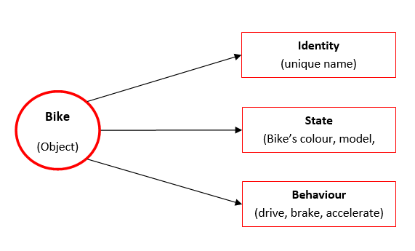

**The role of objects in JavaScript programming**

Objects play a fundamental role in JavaScript programming by providing a structured way to model and manipulate data. They serve as building blocks for creating complex data structures and organizing code in a clear and efficient manner. By leveraging objects, developers can encapsulate related data and functionality within a single entity, promoting code reusability and maintainability. Objects also facilitate the implementation of object-oriented programming principles such as encapsulation, inheritance, and polymorphism, allowing for scalable and modular code design.

## **Creating objects in JavaScript**

In JavaScript, there are several ways to create objects. The most common method is by using object literals, where you define key-value pairs within curly braces {}. Another way is through constructor functions or ES6 classes, which provide a blueprint for creating multiple instances of objects with shared properties and methods. Understanding the various techniques for object creation is crucial for structuring your code effectively and achieving code reusability.

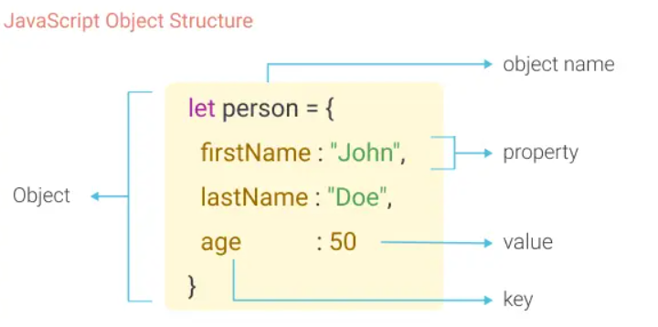

## **Accessing object properties and methods**

Once you have created objects in JavaScript using different techniques as discussed in the previous section, the next step is to understand how to access their properties and methods. You can access object properties using dot notation or square brackets depending on the context. Similarly, methods within an object can be accessed and executed by calling them with parentheses. Understanding the syntax and nuances of accessing object properties and methods is fundamental for manipulating data and performing operations within your code efficiently.